Last summer I was part of a team that was deeply immersed in writing the proposal for what became the ParkLife project. It was an exciting proposal to write. Nesta, a UK innovation foundation, was partnering with the Heritage Fund and Community Fund to support ‘protoyping’ projects that would test new ways that data and digital could help to create more sustainable operating models for parks. This was an excellent opportunity to develop a Living Lab project that would co-design new uses of data and technology to help improve the city for people.

Our project proposed to create a ‘data toolkit’ that would provide data to help park managers and users better understand how parks are used and valued and to better focus investments in parks.

We were thrilled when the proposal was successful. We knew exactly what we intended to do, and we had a great team with a wide range of experience, covering skills from co-design to coordination, park management to citizen science to end-to-end Internet of Things systems.

We had thought through many of the details and created a comprehensive project plan, guided by questions in the application form such as:

* Which people, groups and stakeholder organisations are interested in finding a solution to this and why?
* How will you involve relevant groups in developing your idea? and
* How will you be sure you are including the insights from relevant stakeholders and users in your project development?

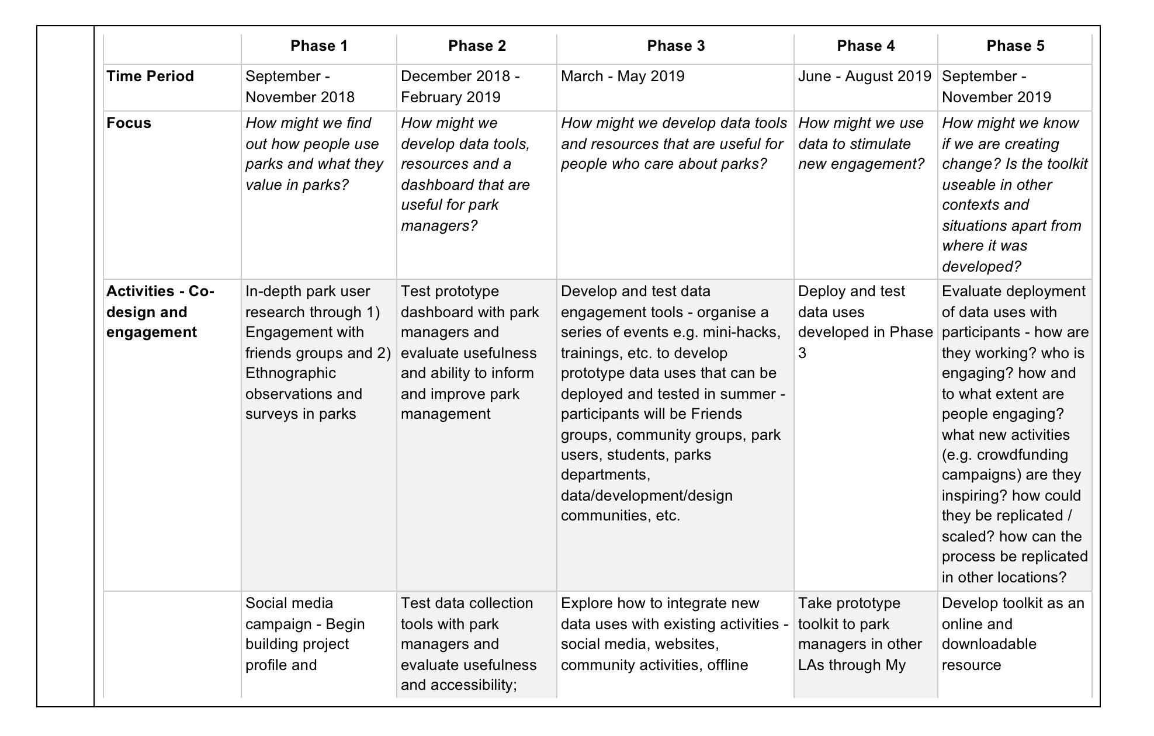

My role on the project was to help guide the co-design process. That would mean working closely with park managers and park stakeholders - including Friends of Parks groups, community councils and park users - to understand their values and priorities and how the project would create benefit for them.

It didn’t take long for our nicely ordered plan to meet reality. As the weeks and months went on, two challenges became apparent.

First, co-design takes time. A lot of time. For example, in the original proposal we envisioned that we could carry out our ‘user research’ plan - effectively surveying people in parks - by employing University students and members of Friends groups to do the work. However, in practice this involved finding someone to lead the user research, designing the survey, advertising for interested students and Friends groups members to work with us, training them, and then actually doing the work. Compiled with a number of delays in other aspects of the project, what I had envisioned as a relatively straightforward piece of work to be done in the first month or two of the project wasn’t actually completed until almost eight months in.

Or take another example: Before we could host our first co-design workshop, we needed to reach out to the four participating park community groups to tell them about the project. Then we needed to find a suitable date where enough members of the core team could attend as well as the community groups. With four separate community groups and four meetings to fit into everyone’s calendars, this took quite some time to organise and implement.

Second, co-design requires finding people who are interested in co-designing with you.

This project asked an open-ended question: ‘How might we use data to improve our parks?’ In order to answer this question, we needed to find people who were interested in data and interested in parks.

We invited Friends of Parks groups and other community members to join a number of workshops around the city. Attendance and participation varied widely by the type of people involved in the park. One workshop had 40+ people, while another had only 3, despite our best efforts at recruitment.

We got some interesting ideas out of the workshops, but when they were finished, we were still fairly far off the original ambition of having groups of people around the city actively engaged in co-designing and testing new applications of data in parks.

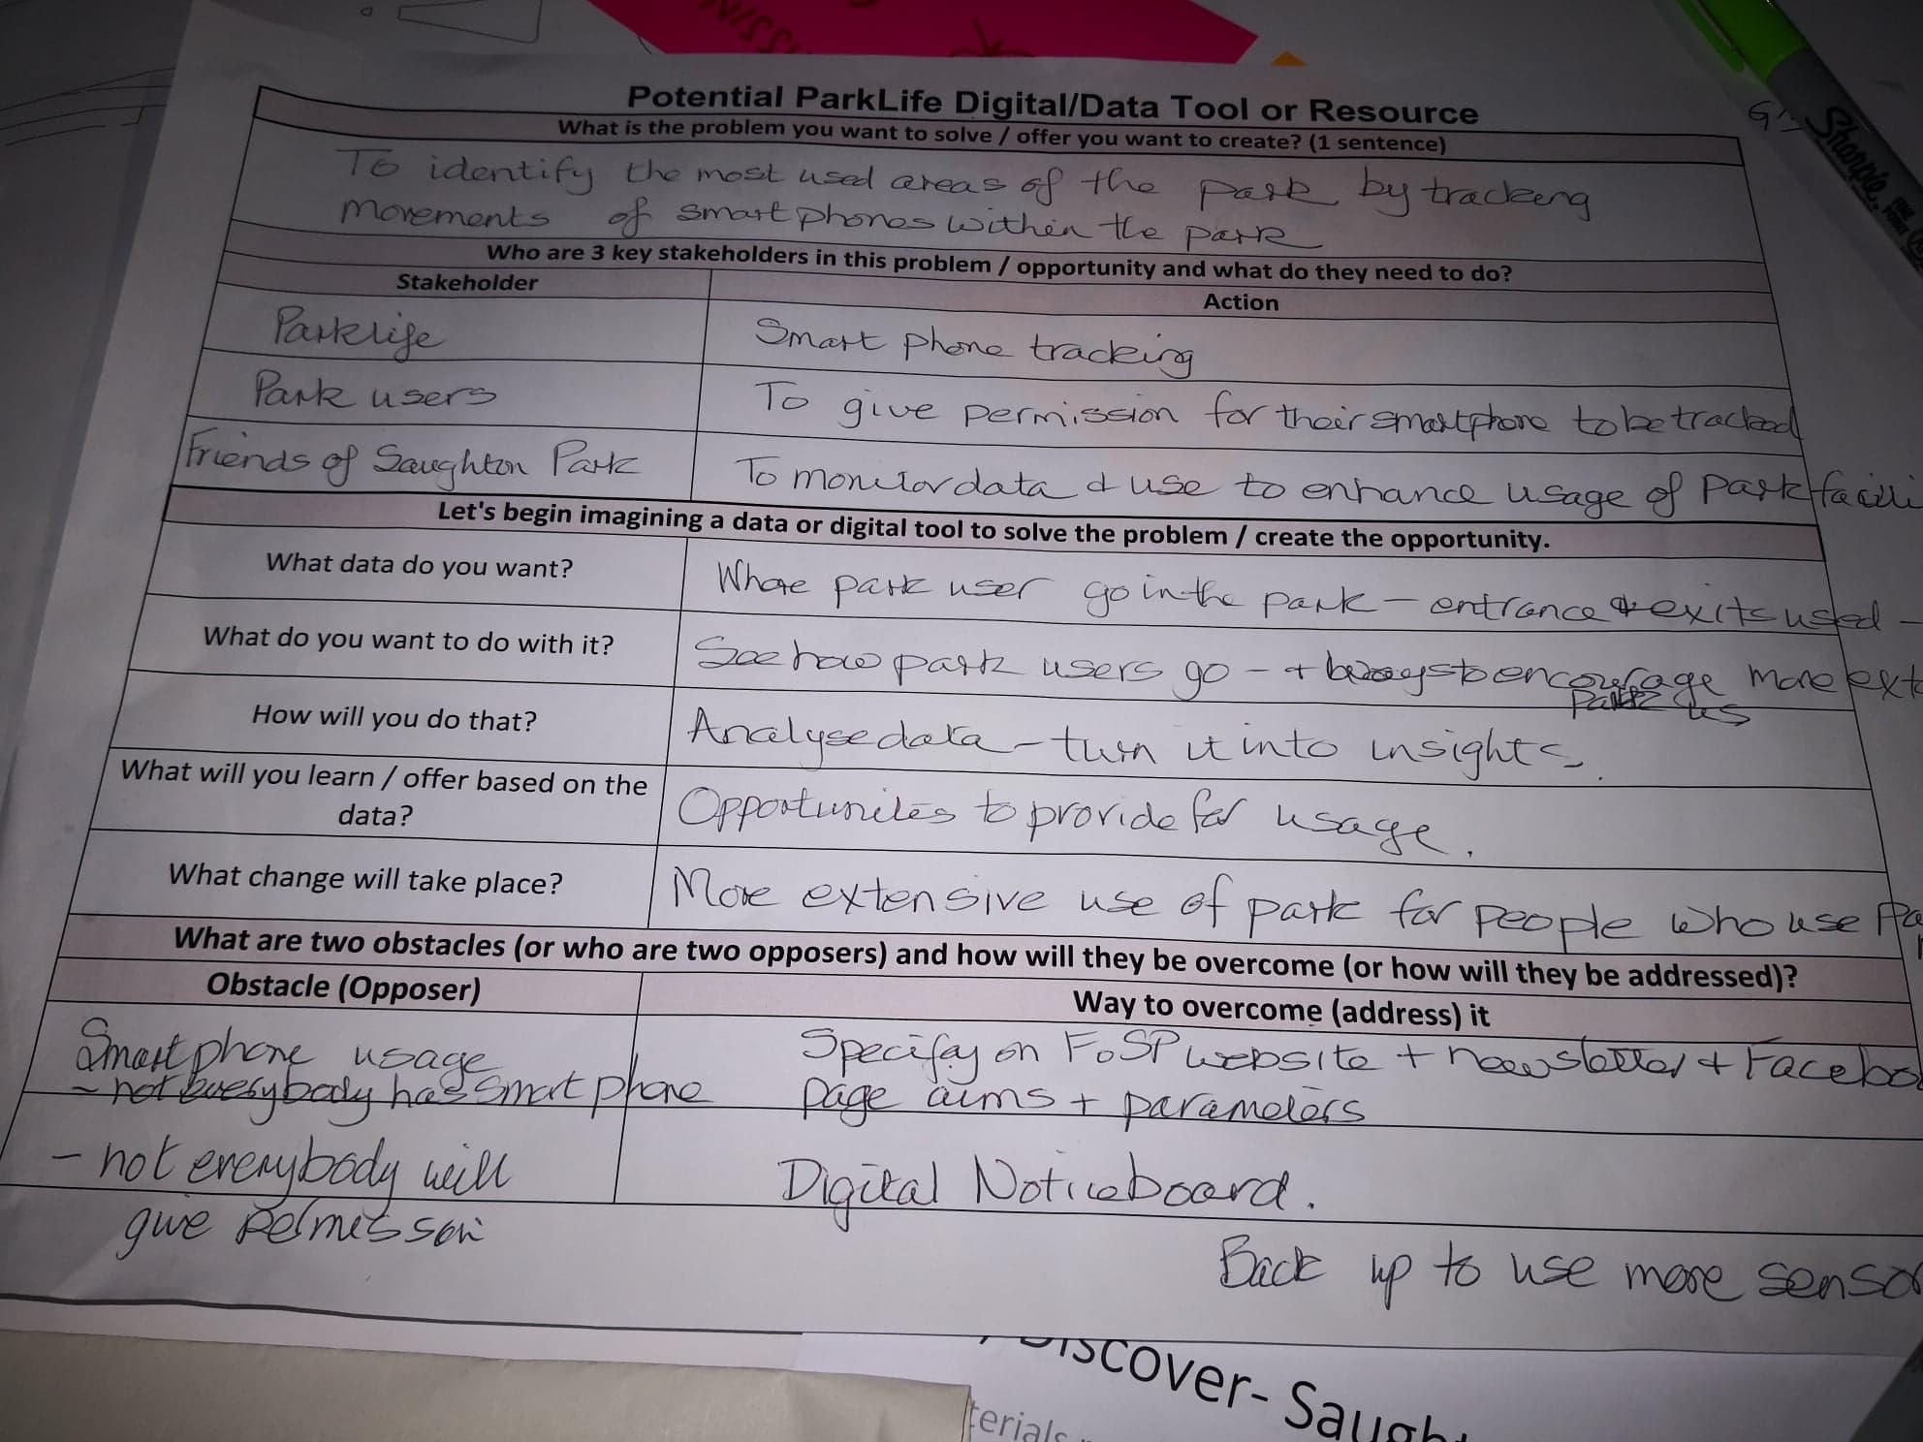

We’re nearing the end of the project now, and while we’ve checked the box of making valiant attempts at co-design, there’s a little nagging voice that says, surely you could have done better. What if we had had more time or tried to push things along faster? What if we had worked harder to find people to co-design with us, had hosted more events and different types of events to reach different people? Sure, it’s possible we might have come closer to achieving our ambitious plan. Or maybe not.

For now, I’ll walk away with a few valuable insights and lessons for the future:

1. Just because in principle you have the right relationships in place doesn’t mean that things will happen quickly. Make sure to account for the logistical time frames of setting up co-design activities with different types of stakeholders on different time schedules in multiple locations around the city.
2. Carefully consider the scope of your project. An innovation project spanning multiple sectors with speculative questions will need input from a lot of different actors. Can you realistically get that input? If it is necessary, start reaching out to as many people as possible early on. Before organising events, put out some feelers to see what the response might be. Find experienced people who have credibility with the people who you want to attend to help you plan and market the events.
3. Manage your expectations. Think very very realistically about who might engage with your initiative, and think very very practically about how they might do that. It’s exciting to you because you’re leading it. If it’s part of your work, you’re paid to do it. But what will interest someone to volunteer their time to participate - and ideally to stay involved over a period of time? Your project might genuinely be valuable, meaningful and important, but that doesn’t mean you will find 100 or even 50 or even 20 people to go on this journey with you. And that’s okay. Maybe for now you only need 5. Or even 2.

Finally, there are many people with extensive experience in co-design and many guides to help you figure it out. But every project is different, and it will always be a process, with learning and mistakes. Take some time to reflect, make some notes, and go out and try it again.